Week 4:

* Show initial sketches to the client and get feedback

Feedback:

* Quick access to data from last week, last month, last 6 months etc. might be good, with the ability to add brief notes etc? (maybe even track their child’s change in myopia prescription… stretch)
* For example, if their child is not spending enough time outdoors and they decide to do something about it (e.g. enroll them in outdoor tennis classes on Saturday afternoons) it would be good for them to be able to tag the start and end dates of the tennis classes for example, so they could see whether it was having the desired effect.
* scroll-down approach will be problematic once there is a reasonable amount of information. The intent is for parents to use the app over years, so they need to be able to see back over long periods in a summarized manner.
* Interested in including UV information

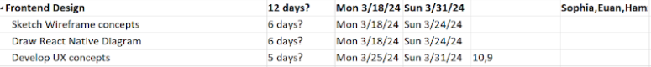

Week 4: Frontend team meeting notes:

* Talk to team about connecting sensor via bluetooth
* Create components

**Tasks on agenda:**

* **Sketch wireframe concepts**
* **Draw a React Native Diagram**
* **Develop UX concepts (team)**
* ***Early user testing with mockups***
* *Next team meeting & timeframes*

Develop UX concepts:

* What pages to include/omit
  + What are stretch goals?
  + What data can the backend team provide?
    - UV
    - Monthly/yearly data
* Colour scheme
* Weekly or daily design?
* Minamalist vs maximalist design
* MVP

**Pages:**

* Loading/ opening screen
  + Spinning Icon
  + Myopia facts/tips at bottom of screen (with help from back end team)
* Summary screen (welcoming)
  + Instructions for how to use app/what app does
* Log in/sign up screen
  + *Single vs multiple children*
* Home/sun ring design
  + *Daily vs weekly design*
  + *Sun safety reminders*
* Hourly data view
  + *24 hours*
  + *UV information?*
  + *Sunrise / sunset information*
* Weekly data view
  + Add in notes on sunglasses? Cap?
  + Sunscreen?
  + Minimum viable product?
* Monthly view
  + *Separate page or access through scrolling?*
    - *Year view* 
      * *Separate?*
      * *Seasonal? e.g. winter vs summer for larger trends*
      * *Add in notes*
* Information page
  + *How do we separate into sections?*
  + *FAQ - e.g. about sensor and cloudy/sunny weather impact*
  + *Sun safety & UV radiation*
  + *Studies and information/treatment options for myopia*
* UV page / UV sensor
* Settings
  + *What categories do we need?*
  + *What categories do we want?*

| Week 5 | | |
| --- | --- | --- |
|  | Tasks: | Target date: |
| Sophia | * Landing page | 27/03/24 |
| Hamzah |  |  |
| Euan |  |  |
| Feedback: | | |



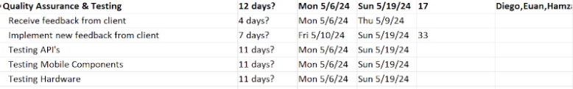

UV data:

* Is it useful to clients?
  + Need more pushes? Data storage
* Is it useful to researchers?
* Ask in client meeting?

Components:

* Text & emoji

Pages to wireframe:

* Loading screen
* Welcome page - sign up at bottom
* Sign-in/Sign-up page
* UV mockup?
* Connect/pair sensor page
* Instruction page
* Landing page
* Statistics page
  + Histogram (phone usage example)
* Information page
* Settings page (Accessibility, Help, Feedback, Security, BT, Reminders, Account)

Main components to try get done by wednesday: (by me mainly)

* Sunlight ‘ring’ / connected or disconnected view
* Bottom nav menu (part of all pages)
* Hourly view
* Monthly views (reuse ring)
* Yearly view (reuse ring)

Colour schemes